**DATASCIENCE ASSIGNMENT**

**Upendra Kadre**

**C 69**

**1710505**

**ASSOCIATION RULES -APRIORI ALORITHM**

1)Import libraries and dataset .

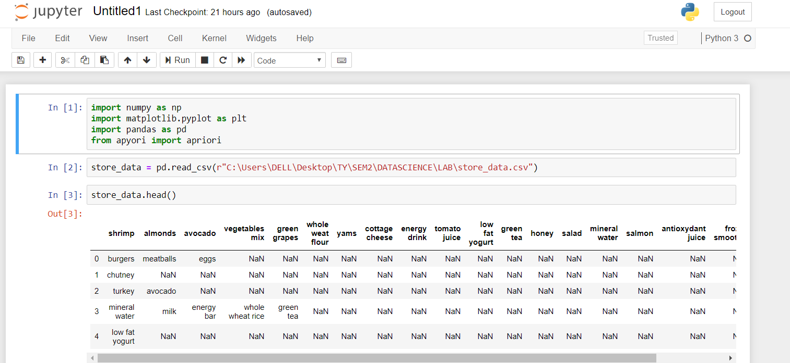

2)When we import dataset , making header as none.

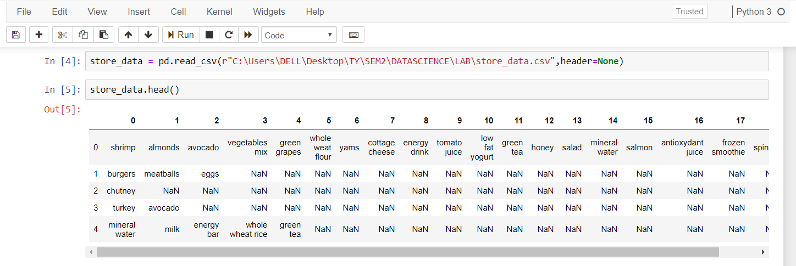

3)Data Preprocessing:

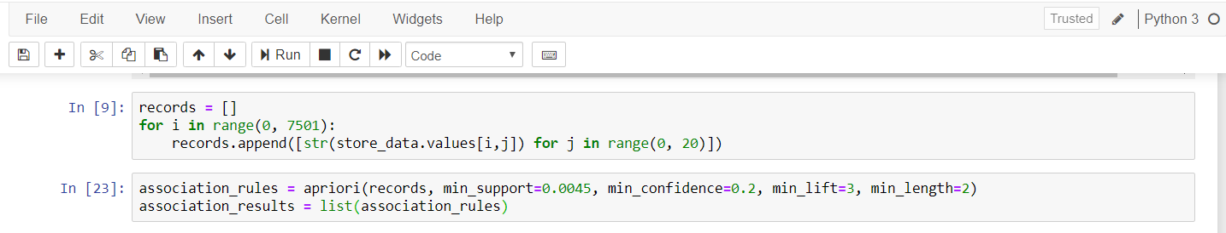

4)To display the association rules stored in association_results list.

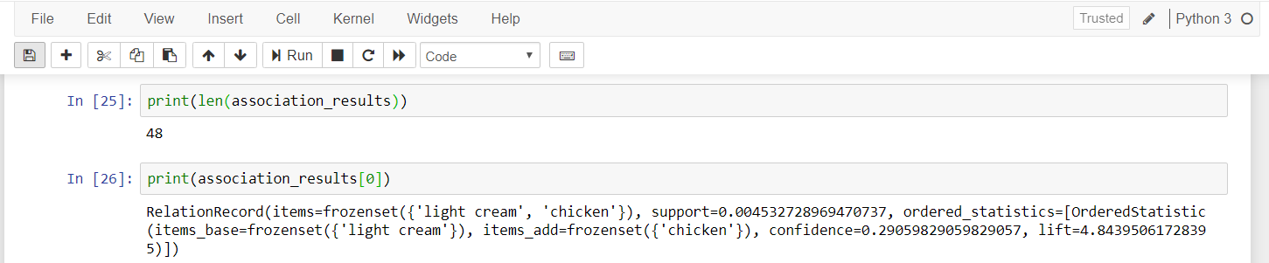

5)To display support,confidence,and lift for each rule in more detail.

